
CC-215-L: Database Systems Lab

Faculty of Computing & Information Technology

BS(IT/CS) Morning - Fall 2023
LAB – 05(ODD)

The objective of this lab is to:
- SQL Joins
- Subqueries
- Previous Content
Course & Lab Instructor: Dr. Asif Sohail
LAB TIMING : 90 MINS
TOTAL MARKS : 45
Task 01: [10 marks]
EACH QUERY CARRIES 1 MARK
- Display all of the 4 locations with number of employees working in that location
SELECT LOC,COUNT(*) NUM_EMP
FROM EMP
NATURAL JOIN DEPT
GROUP BY LOC
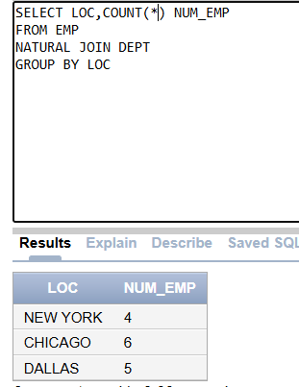
- Display the maximum amount of salary given to an employee in the year 1980
SELECT MAX(SAL)
FROM EMP
WHERE EXTRACT(YEAR FROM HIREDATE) = 1980;
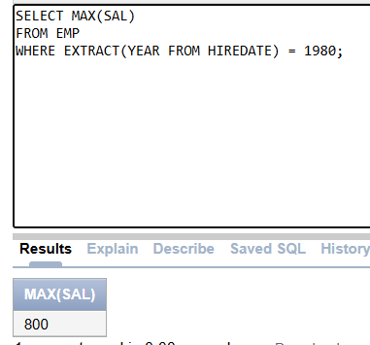
- Display the employees along with the name of their managers.

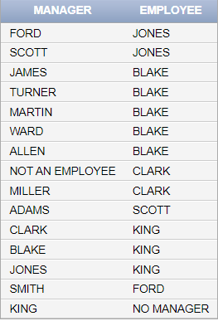

SELECT E.ENAME MANAGER ,M.ENAME EMPLOYEE
FROM EMP E
LEFT JOIN EMP M
ON E.MGR = M.EMPNO;
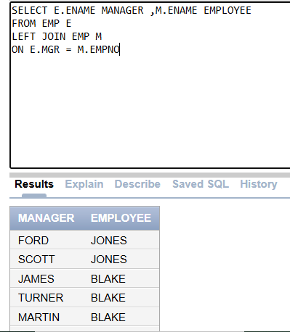
- Write an SQL query to display the number of employees working under each manager in department no 10. (JOINS ARE MUST)

SELECT M.ENAME AS MANAGER ,COUNT(*) NUM_EMP,E.DEPTNO
FROM EMP E
JOIN EMP M
ON E.MGR = M.EMPNO
WHERE E.DEPTNO = 10
GROUP BY M.ENAME,E.DEPTNO;
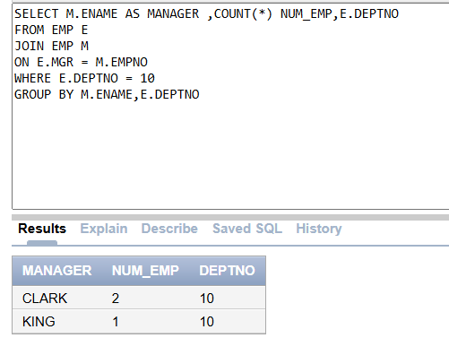
- Display the employees earning more than the average salary.

SELECT *
FROM EMP
WHERE SAL > (SELECT AVG(SAL) FROM EMP);
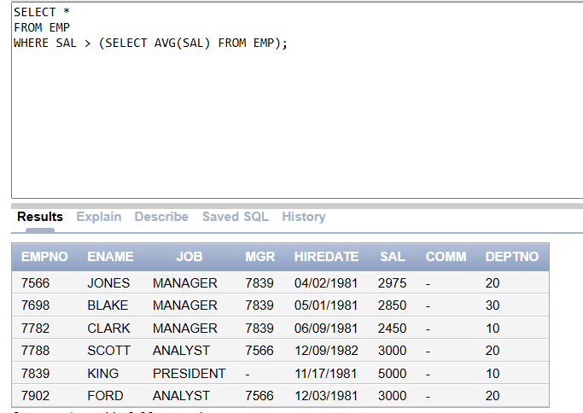
- Display the department name having maximum number of employees
SELECT DNAME,COUNT(*) NUM_EMP
FROM DEPT
NATURAL JOIN EMP
HAVING COUNT(*) = (SELECT MAX(COUNT(*)) FROM EMP GROUP BY DEPTNO)
GROUP BY DNAME;
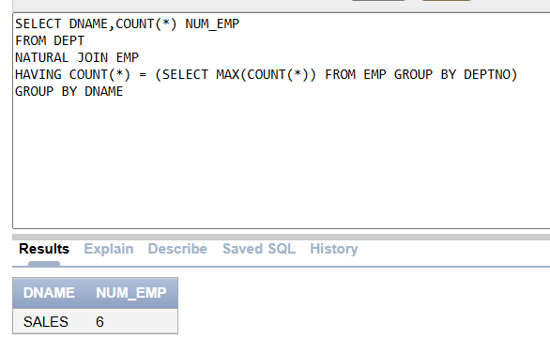
- Find the department with the highest total salary.
SELECT DNAME
FROM EMP
NATURAL JOIN DEPT
HAVING SUM(SAL) = (SELECT MAX(SUM(SAL)) FROM EMP GROUP BY DEPTNO)
GROUP BY DNAME;
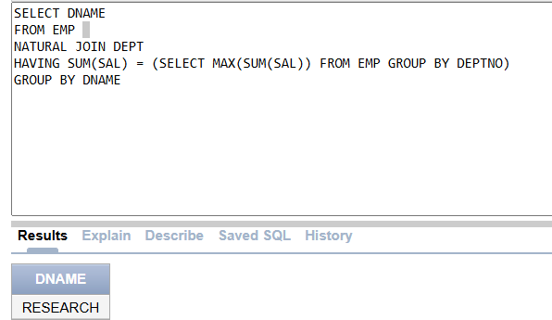
- Retrieve a list of employees who have the same salary grade as their managers.
SELECT E.ENAME EMP, M.ENAME MGR,S.GRADE
FROM EMP E
JOIN EMP M
ON E.MGR = M.EMPNO
JOIN SALGRADE S ON E.SAL BETWEEN LOSAL AND HISAL
AND M.SAL BETWEEN LOSAL AND HISAL;
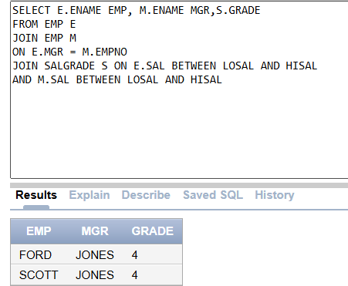

- Retrieve a list of employees (employee name and manager's name) along with their respective managers. For an employee without manager, display “No Manger”.
SELECT E.ENAME EMP ,NVL(M.ENAME ,'NO MANAGER')MGR
FROM EMP E
LEFT JOIN EMP M
ON E.MGR = M.EMPNO;
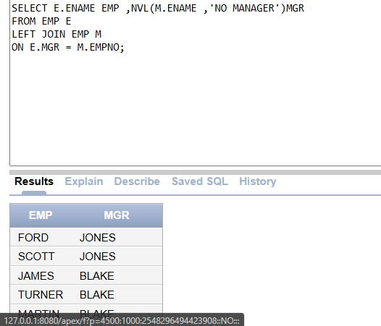
- List all employees in department 20 who have a manager in department 10.
(only to be solved by subquery)

SELECT *
FROM EMP
WHERE DEPTNO = 20
AND MGR = (SELECT MGR FROM DEPT WHERE DEPTNO = 10)
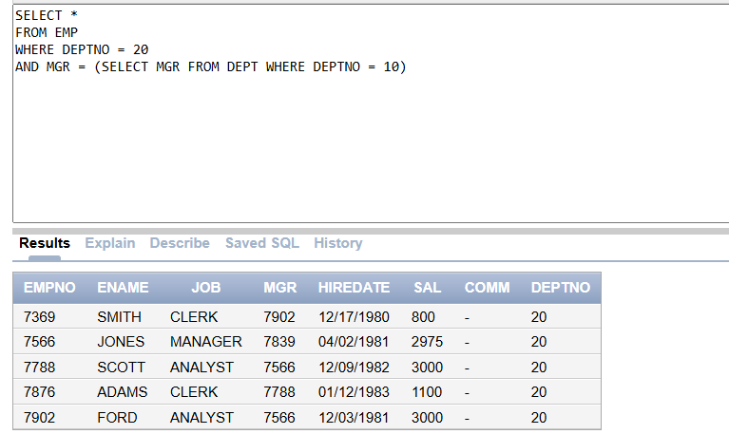

Task 02: [16 marks]
EACH QUERY CARRIES 2 MARKS

- Write an SQL query to display the department having more number of employees than ‘sales department’.
SELECT DEPTNO,COUNT(*) NUM_EMP
FROM EMP
GROUP BY DEPTNO
HAVING COUNT(*) > (SELECT COUNT(*) FROM EMP WHERE DEPTNO = (SELECT DEPTNO FROM DEPT WHERE DNAME = 'Sales'));
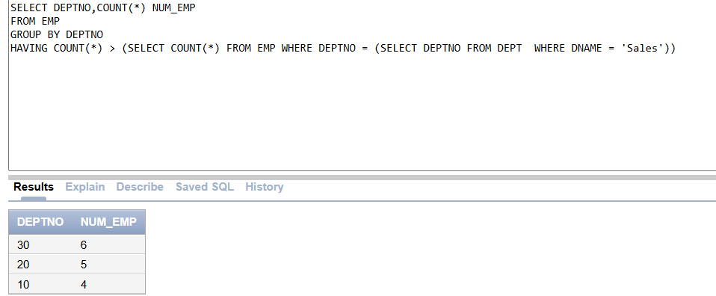
- Display the following output. (DON’T USE ANY ANALYTICAL FUNCITON)
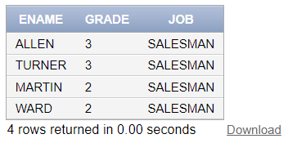
SELECT ENAME,GRADE,JOB
FROM EMP
JOIN SALGRADE ON SAL BETWEEN LOSAL AND HISAL
WHERE JOB = 'SALESMAN'
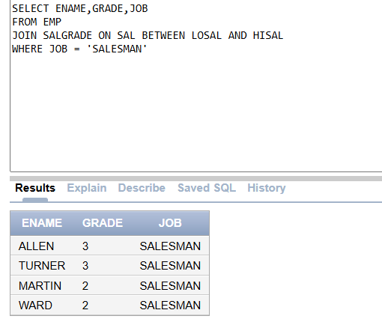
- Write a query to find the High-Achievers w.r.t Salary in each department. Display their Names, Salary, Jobs. The employee with the highest salary should be at the top and so on
SELECT ENAME, SAL, JOB
FROM EMP
WHERE (DEPTNO, SAL) IN (SELECT DEPTNO, MAX(SAL)FROM EMP GROUP BY DEPTNO)
ORDER BY SAL DESC;
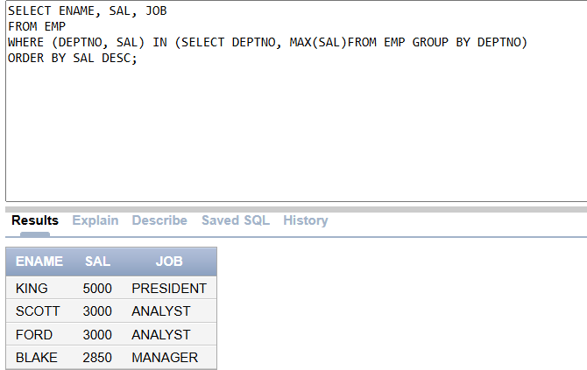
- Find the name of Most Senior and most junior employee

SELECT ENAME MOST_JUNIOR
FROM EMP
WHERE HIREDATE = (SELECT MAX(HIREDATE) FROM EMP);
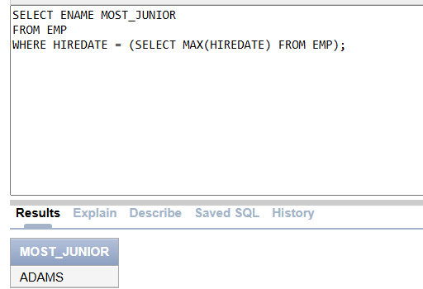
SELECT ENAME MOST_SENIOR
FROM EMP
WHERE HIREDATE = (SELECT MIN(HIREDATE) FROM EMP);
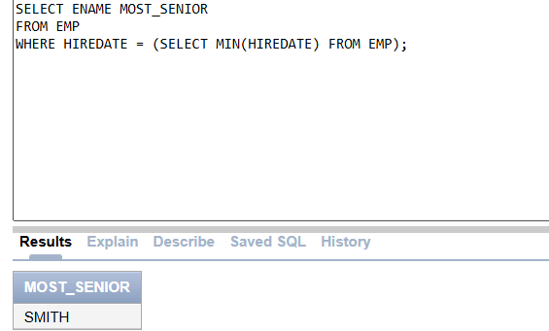
- Find employees who have the same dept and job as employee ID 7369, but not including employee ID 7369 (USE SUBQUERY ONLY)
SELECT ENAME
FROM EMP
WHERE DEPTNO = (SELECT DEPTNO FROM EMP WHERE EMPNO = 7369)
AND JOB = (SELECT JOB FROM EMP WHERE EMPNO = 7369)
AND EMPNO <> 7369;
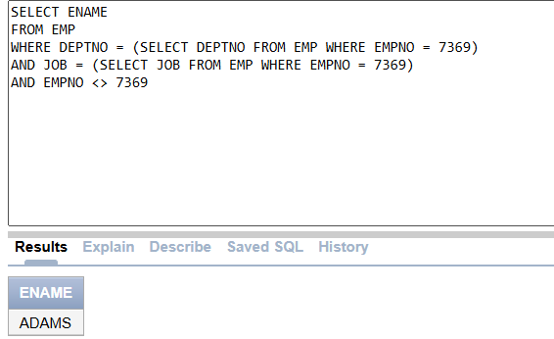
- List all employees whose salary is greater than the average salary of the employees working in department 20.

SELECT ENAME,SAL
FROM EMP
WHERE SAL > (SELECT AVG(SAL) FROM EMP WHERE DEPTNO = 20 GROUP BY DEPTNO)
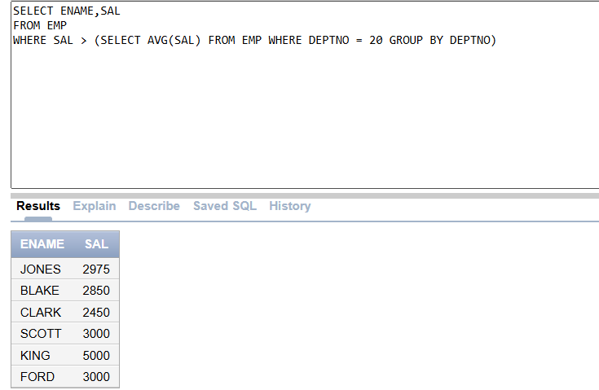

List EMPNO, ENAME, JOB, SAL, DEPTNO, DNAME, RANK, TAX, NET_SAL. Tax is a derived attribute computed on the basis of GRADE. All the employees rank 1 are exempted from tax. For the employees with GRADE 2,3, the tax rate is 10% of the salary. For the employees with GRADE above 3, the tax rate is 12% of the salary. NET_SAL is computed as SAL-TAX.

SELECT E.EMPNO,E.ENAME,E.JOB,E.SAL,E.DEPNO,D.DNAME,GRADE
CASE
WHEN GRADE = 1 THEN 0
WHEN GRADE IN (2,3) THEN SAL * 0.10
ELSE SAL * 0.12 END AS TAX,
E.SAL -
(WHEN GRADE = 1 THEN 0
WHEN GRADE IN (2,3) THEN SAL * 0.10
ELSE SAL * 0.12 END) AS NET_SAL
FROM EMP E
INNER JOIN DEPT D
ON E.DEPTNO = D.DEPTNO
JOIN SALGRADE ON SAL BETWEEN HISAL AND LOSAL
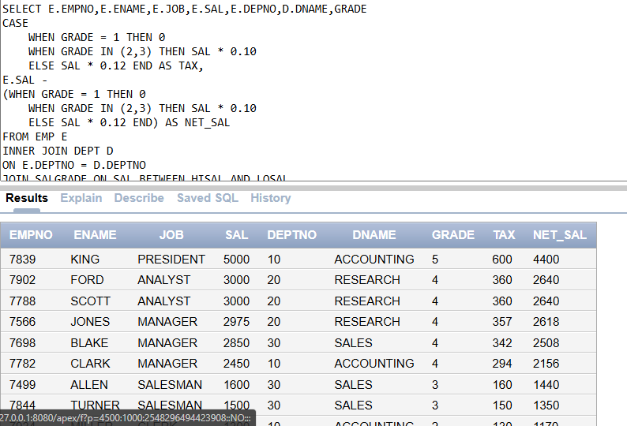
- Display the Department numbers (deptno) and the corresponding department names (dname) from the "DEPT" table along with the total number of employees in each department from the "EMP" table. Include departments with zero employees.

SELECT COUNT (E.ENAME), D.DEPTNO, D.DNAME
FROM EMP E
RIGHT JOIN DEPT D
ON E.DEPTNO = D.DEPTNO
GROUP BY (D.DEPTNO , D.DNAME);
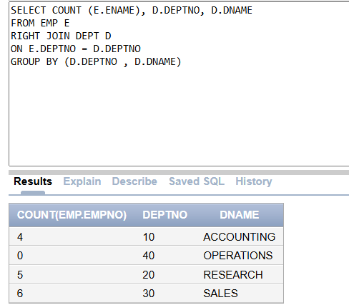
Task 03: [5 marks]
1. Display the output in the given format
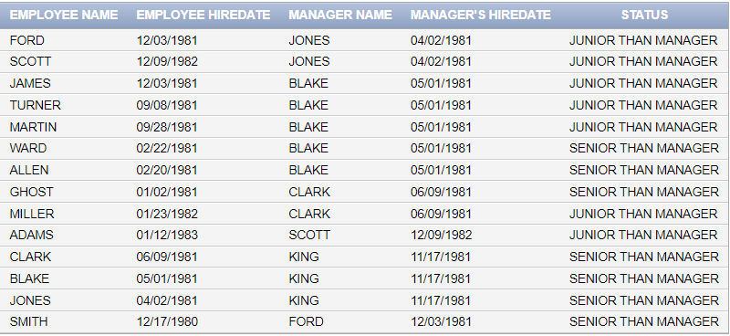
SELECT NVL(E.ENAME,'GHOST') EMPLOYEE_NAME,E.HIREDATE EMP_HIREDATE,M.ENAME MANGER,M.HIREDATE MGR_HIREDATE,
CASE
WHEN E.HIREDATE > M.HIREDATE THEN 'JUNIOR THAN MANAGER'
ELSE 'SENIOR THAN MANAGER'
END AS STATUS
FROM EMP E
JOIN EMP M
ON E.MGR = M.EMPNO;
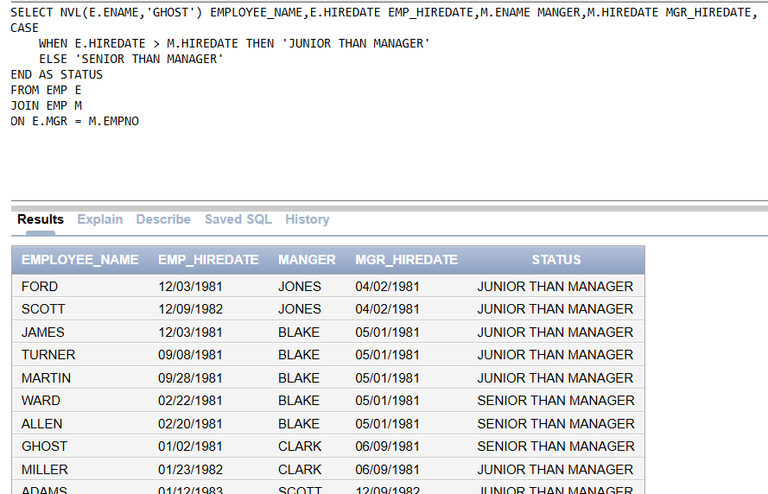
2. Find employees along with their department name, salary grade, and a flag indicating whether their salary is above the department’s average.

Task 03: [5 marks]
VIVA VOCE

